PERSONAL

INFORMATION
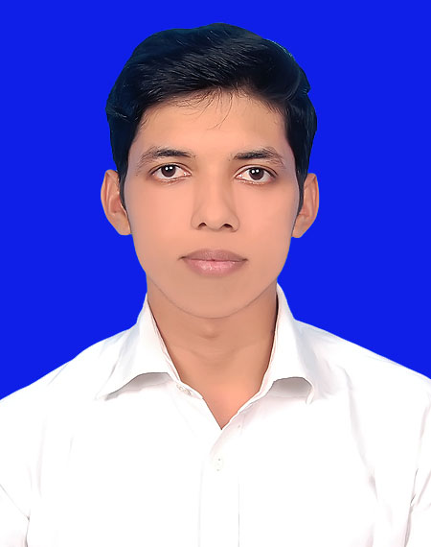

CAREER OBJECTIVE

WORK
EXPERIENCE:

CURRICULUM VITAE
OF
Md Rubel Bhuyan

Kusabo,Kanchan,Rupganj,Narayanganj-1461

+88 01306813848
E-mail Id : mdrubelbhuyan80930@gmail.com

-To Work as a Technical Professional of any fast growing local large company and multinational company and go rapidly with increment Responsibility, Seeking for a challenging role in the area of Technical where I can use my skills for the growth of the organization.

September 2019 – Continuing – momitor assembly (Outgoing qualitiy control - OQC) 5 month Then promotion asst engineer and transfer SMT manufacturing system
Then Continuing - Surface mount technology(SMT)

Best Tycoon (BD) Enterprise Ltd. Of VIVO mobile phone
Main Activities And Responsibilities – OQC
Ensure Mobile Phone Quality Randomly Sampole Basis Take Phone From Production Line Inspection With Quality Standard Ensure Bom Used According Tooo Engineering Instection I tranning all OQC inspector .If Have Any Issuesdealing Pqe Engineering Team

Main activities and responsibilities – vivo SMT

I Know All SMT Work Process SMT MODEL PQC SMT .FAI PQC. MATERIAL PQC. And SMT OQC . My Responsibly OQC SIDE If Have Any Issues Dealing PQE Engineering Team

2. Company Name : Symphony-Mobile (Edison Industries Ltd.Of EDISON GROUP)
Position : IPQC Line Officer In Symphony Mobile Phone
Duration : (1year)

Main activities and responsibilities –
• 1 year Final Quality Control Inspection & Work as Team Leader.
• Employee’s QC Training Makes Work Proficient.
• Aesthetical & Function Problem Report & Inform to production line.
• IPQC Inspection & Work as IPQC Line Leader.
EDUCATION AND TRAINING :

2018 Continuing BSC in EEE - Electrical and Electronic Engineering

University : Manarat International University,Dhaka

CGPA : Appeared
Passing Year : 2022
Diploma in Electronics Engineering

Collage patuakhali Polytechnic Institute,
. Subject : electronics
Board : Bangladesh Technical Education board ( BTEB )

CGPA : 2.96 (Out of 4.00)
Industrial Attachment Walton Service Management System, 2017,3 Month Completed.
Training
- Install Simple Electrical & Electronics Circuits.
- LED,LCD,CRT Television Service.
- Electronic Home Apliance Service.
- Genarator Operation & Maintenance,Electrical Service Connection.
- Interpret Draing & Layout Electrical & Electronics Circuits.

PERSONAL MEMORANDA & BACKGROUND:
. Name : Md. Rubel Bhuyan
Father’s name : Md. Abul Kalam Bhuyan
Mother’s name : Rehena Begum
Date of Birth : 15thJanuary 1997
Sex : Male
Present address :Vill:Charabag, P.O: Ashulia, P.S Ashulia, Dist: Dhaka.
Permanent address : Vill: Muradia, P.O: Muradia,
P.S: Dumki, Dist: Patuakhali.
Nationality : Bangladeshi
Marital Status : Unmarried
Religion :Islam

COMPUTER SKILLS:
Experienced in Windows XP environment & Windows 10 .
Efficient in Microsoft Office Word, Microsoft Power Point.
Efficient in Microsoft Office Excel, Adobe Photoshop.

LANGUAGE SKILLS:
Bengali : Speaking,Listening,Reading,Writing Excellent ( Mother Tongue )
English : Speaking,Listening,Reading,Writing,Well. ( 2nd Language )
OTHERS SKILLS:
* Electronics Device Repair, Electronics Circuit Design.
* Pc-Hardware Maintenance.
* Basic Works Mobile & Electronics Technology.
* Electrical House Wiring, Home IPS System.
REFERENCE:
1 Md.Masudul-Hasan
Senior Engineer,
Quality Control (OQC )
Best Tycoon(BD) Enterprise Ltd, VIVO
Cell : 01866218124
E-mail: masud.stamford@gmail.com

2. Md.rakib Remu
Asst Engineer,
Quality Control (SMT )
Best Tycoon(BD) Enterprise Ltd, VIVO
Cell : 01980862150

Sincerely Yours

Md Rubel bhuyan | Date | :

